**Answers of “Review Questions” in PDF file**

Page 11

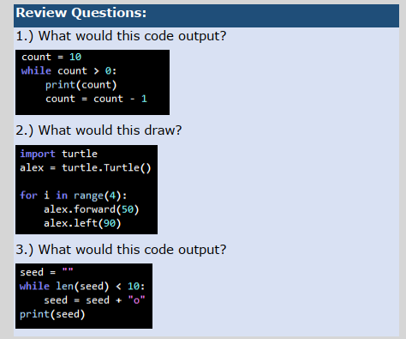

1. 10 to 1 printed
2. An square with length of 50
3. A pile of seeds with right-triangular shape

Page 21

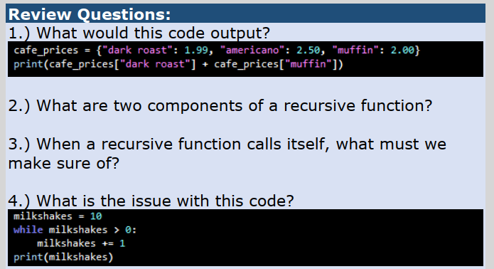

1. Output => 4.49
2. Recursive call and base case
3. Base case, that’s the stopping criterion for the recursive call
4. It will never ends and results in infinite loop !!! (incorrect stopping criterion)

Page 32

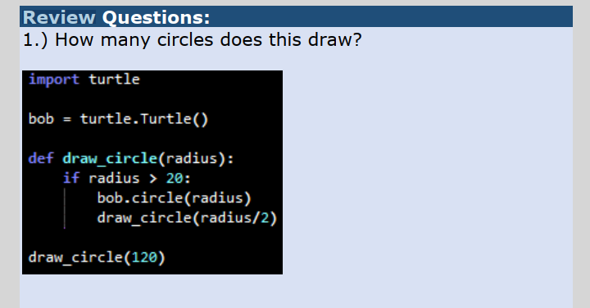

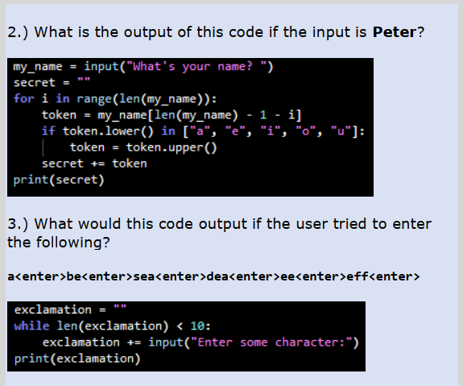

1. Three circles with different radiuses (120 , 60 and 30)
2. Peter => rEtEP
3. abeseadeaee